III. Refactoring Report
- Before vs After Description
PATTERN 1: SINGLETON PATTERN
Location: Backend - Database Configuration
The Original Implementation [BEFORE (Without Singleton)]
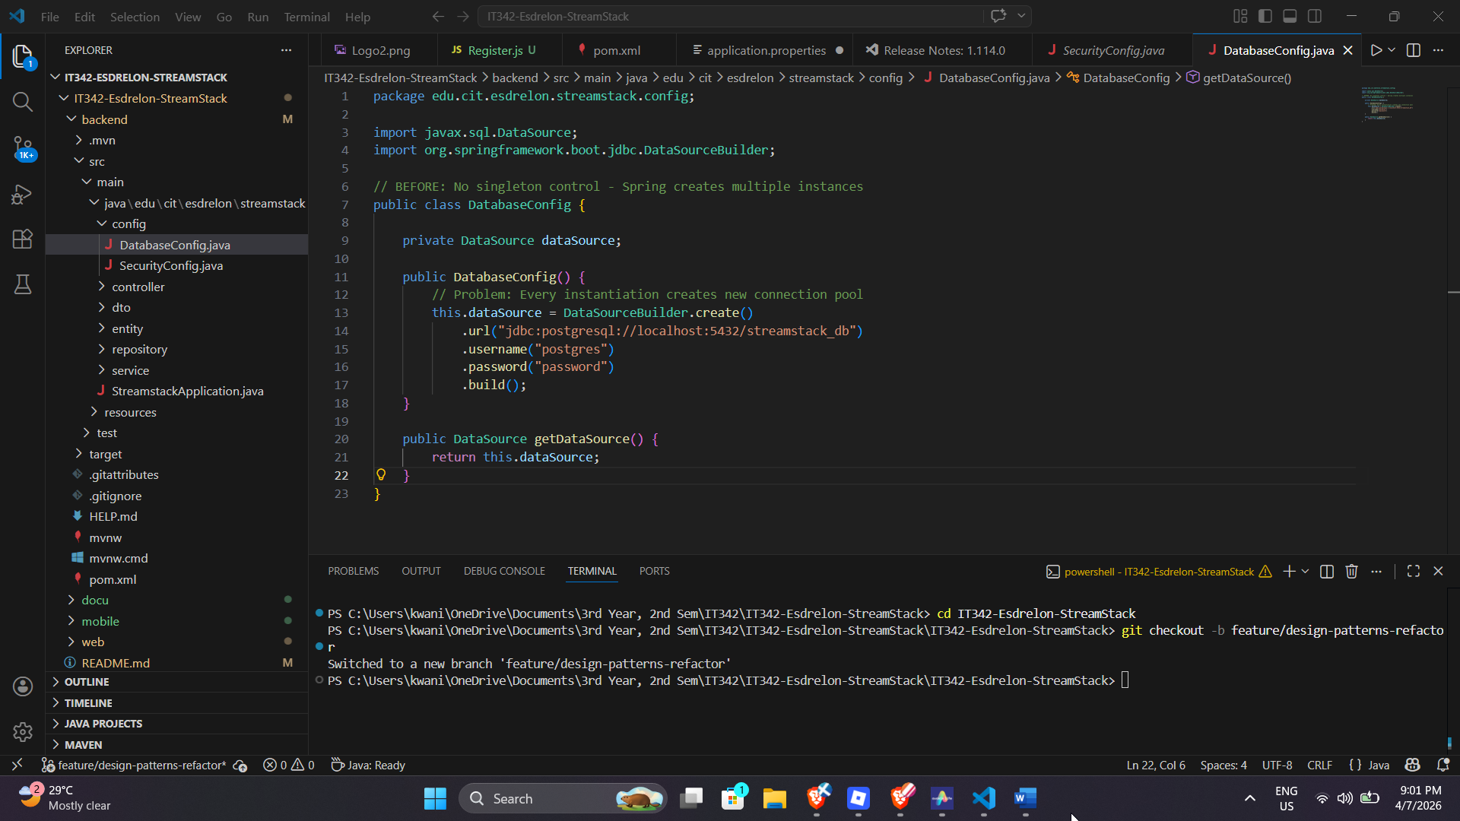

Problem: Multiple database configuration instances could be created, wasting resources.
After the Implementation [AFTER (With Singleton Pattern)]
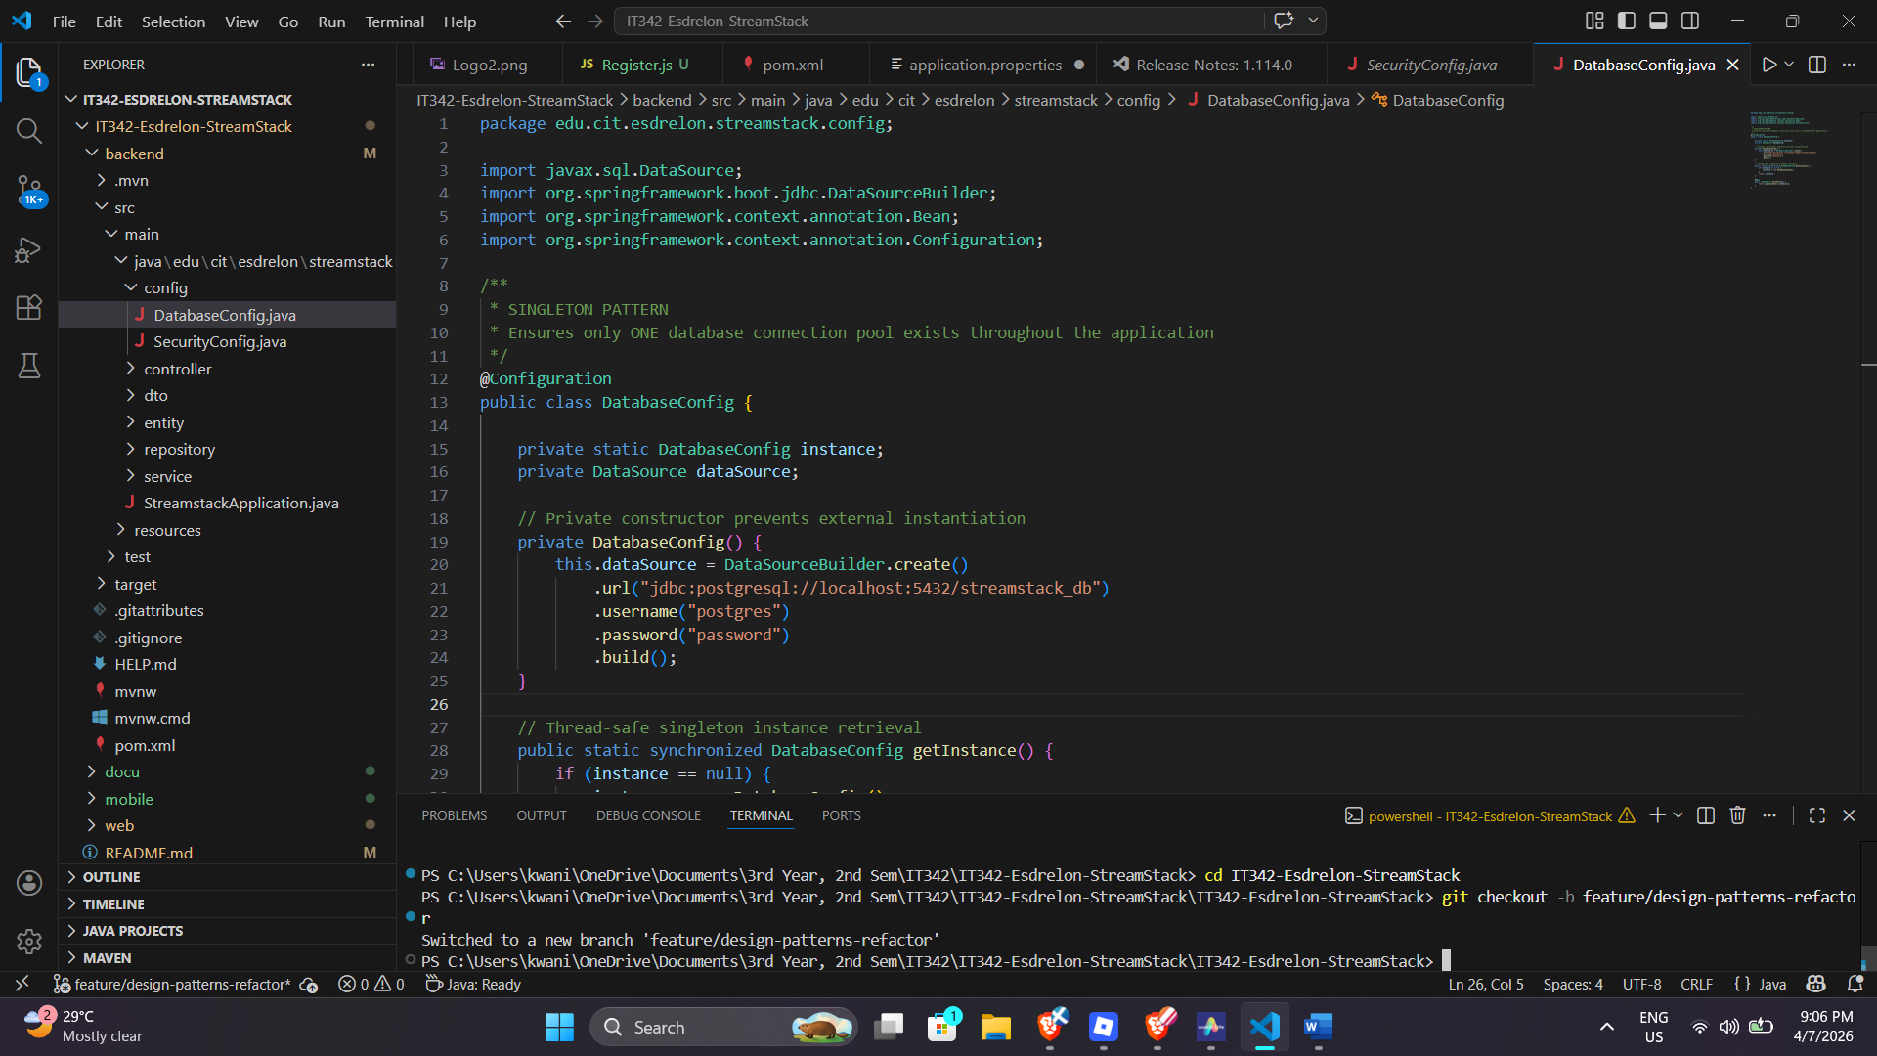

Benefits:
- Only ONE database connection pool
- Memory efficient
- Consistent configuration across application

PATTERN 2: FACADE PATTERN
Location: Backend - AuthService
The Original Implementation [BEFORE (No Facade)]
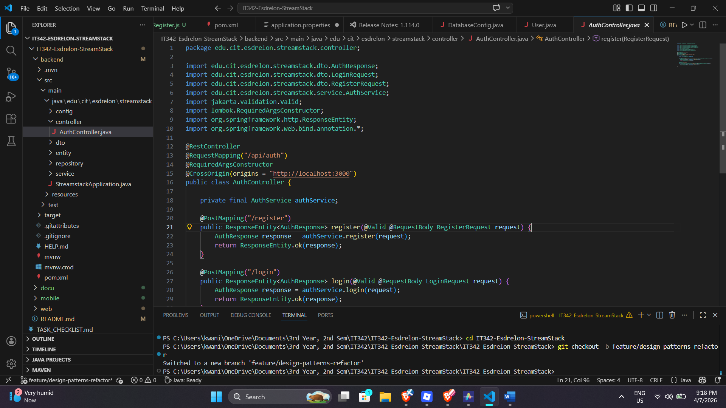

Problem: Controller directly interacts with multiple services, increasing complexity.
After the Implementation [AFTER (With Facade Pattern)]
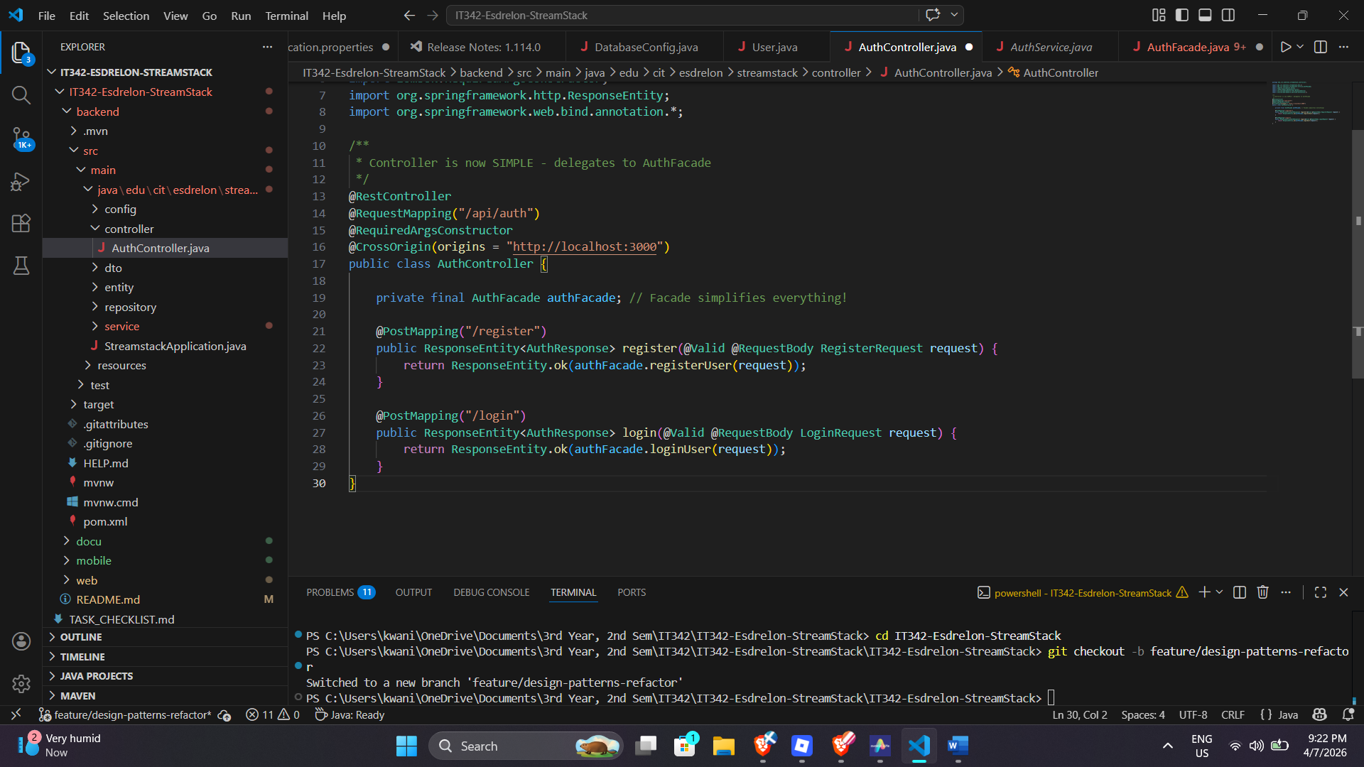

Benefits:
- Controller is clean and simple
- All authentication logic in one place
- Easy to test and maintain

PATTERN 3: STRATEGY PATTERN
Location: Backend - Authentication Strategy
The Original Implementation [BEFORE (Without Strategy)]
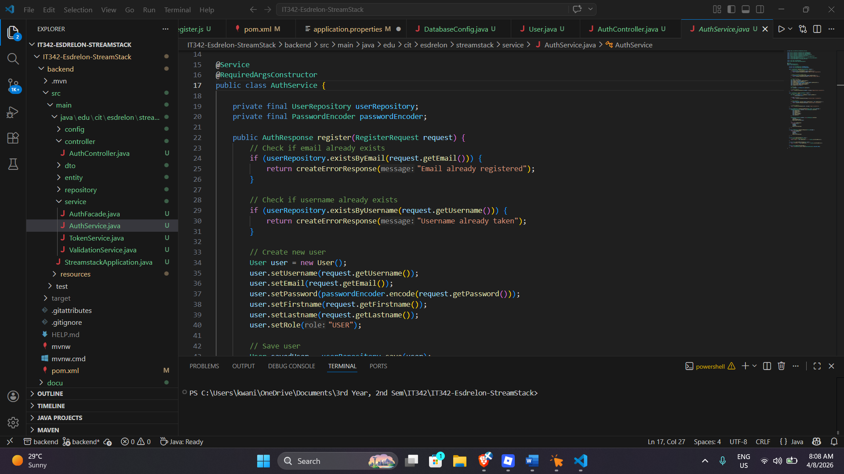
Problem: Hard to add new authentication methods (Google OAuth, Facebook, etc.) without modifying existing code.
After the Implementation [AFTER (With Strategy Pattern)]
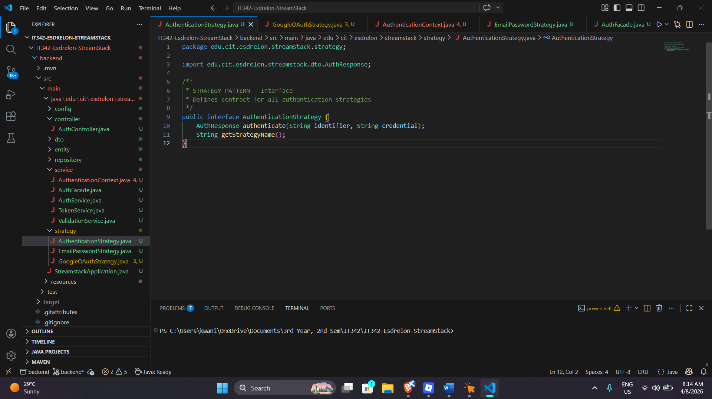
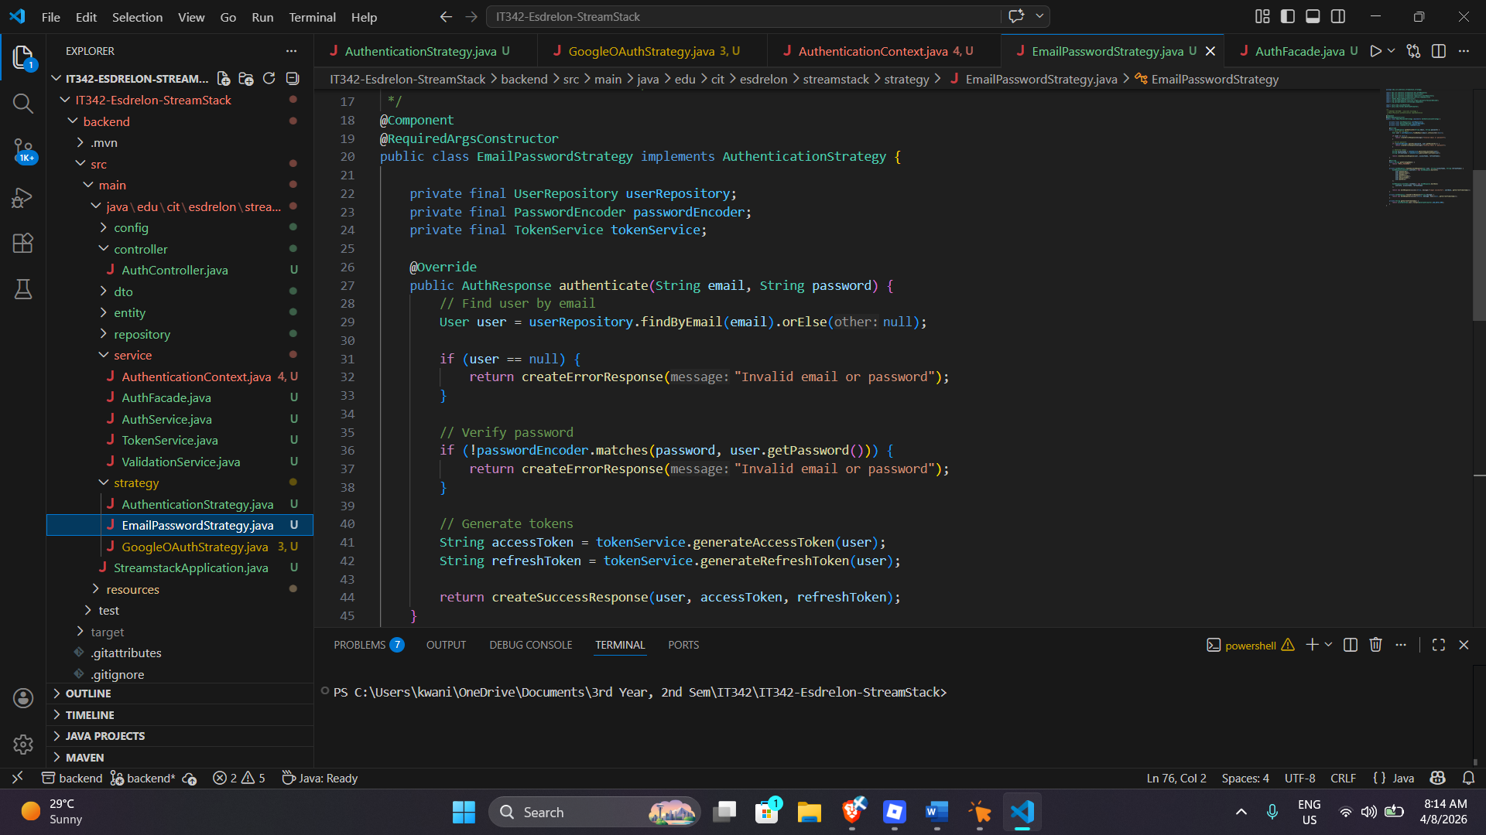
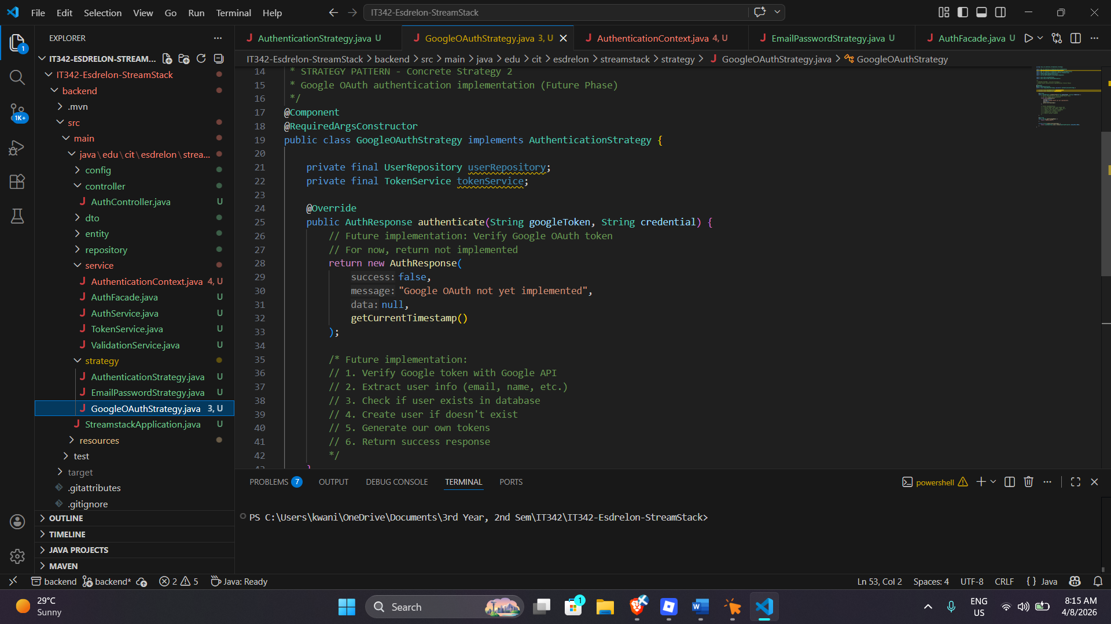
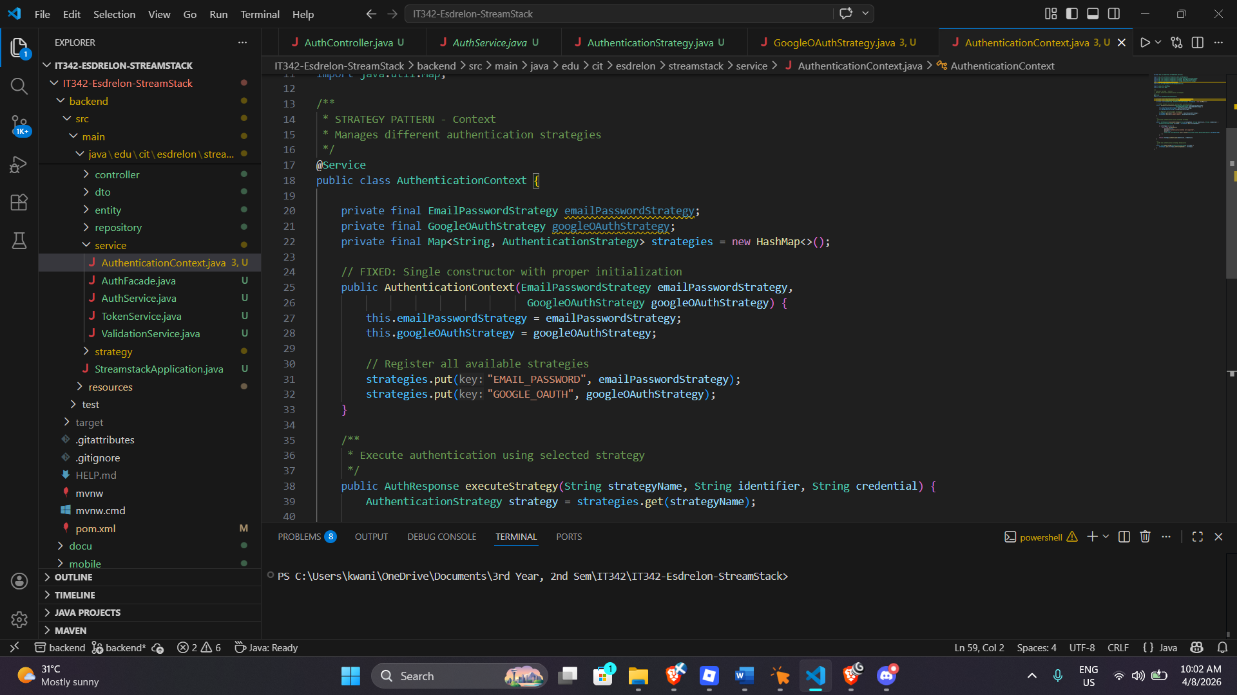
Benefits of Strategy Pattern:
- Easy to add new authentication methods (OAuth, SAML, etc.)
- No need to modify existing code
- Each strategy is independent and testable
PATTERN 4: OBSERVER PATTERN
Location: Web Frontend - User State Management
The Original Implementation [BEFORE (Without Observer)]
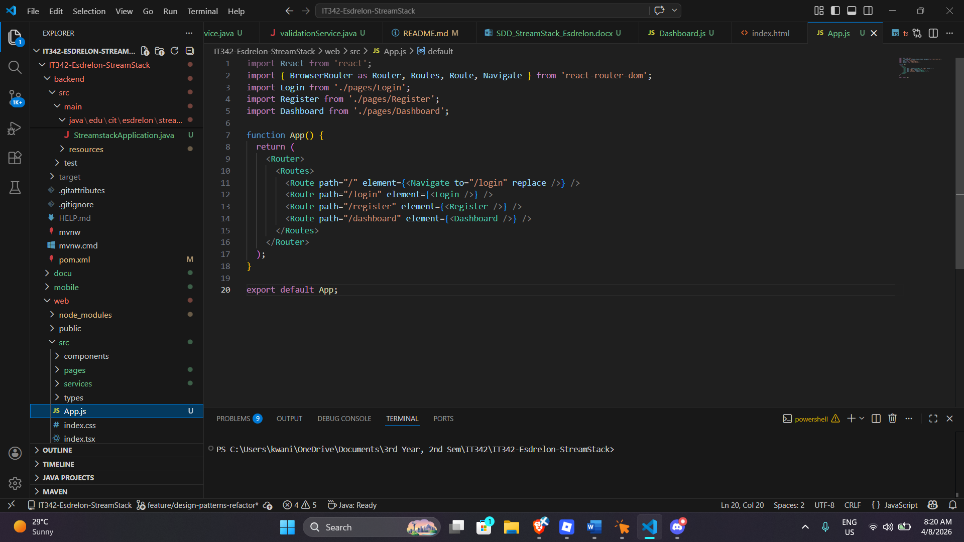
Problem: Components don't automatically update when user state changes.
After the Implementation [AFTER (With Observer Pattern)]
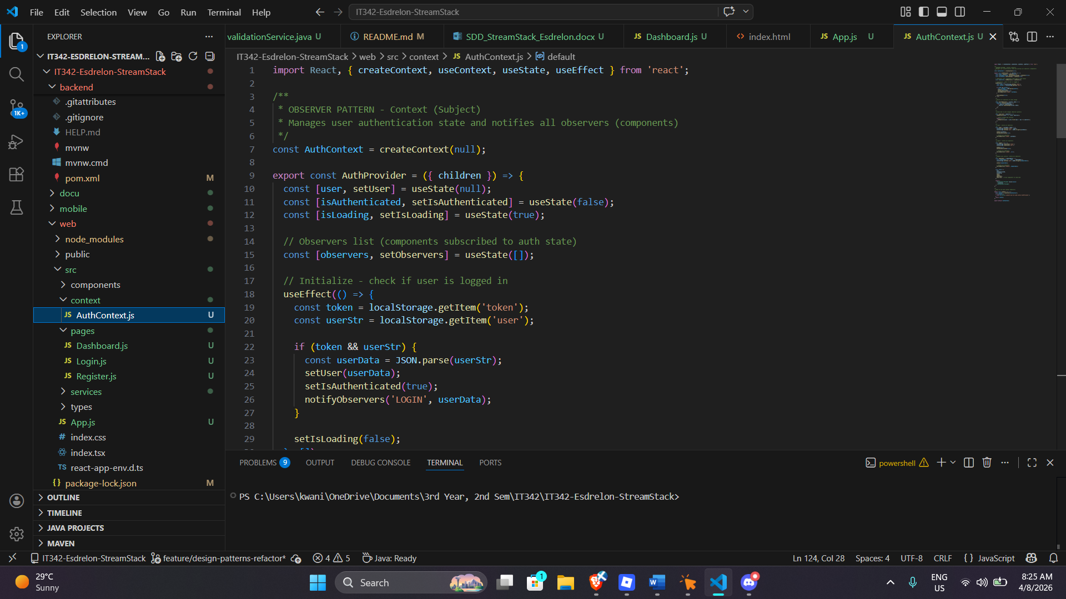
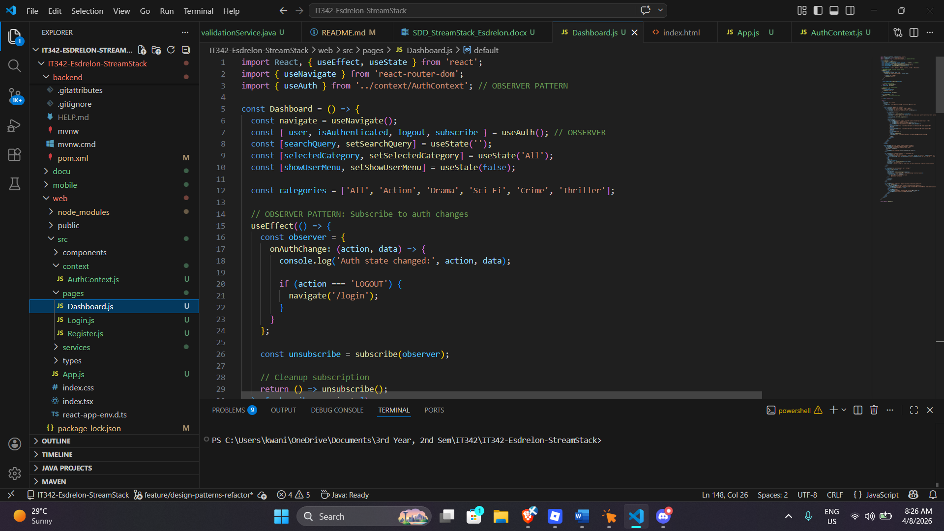
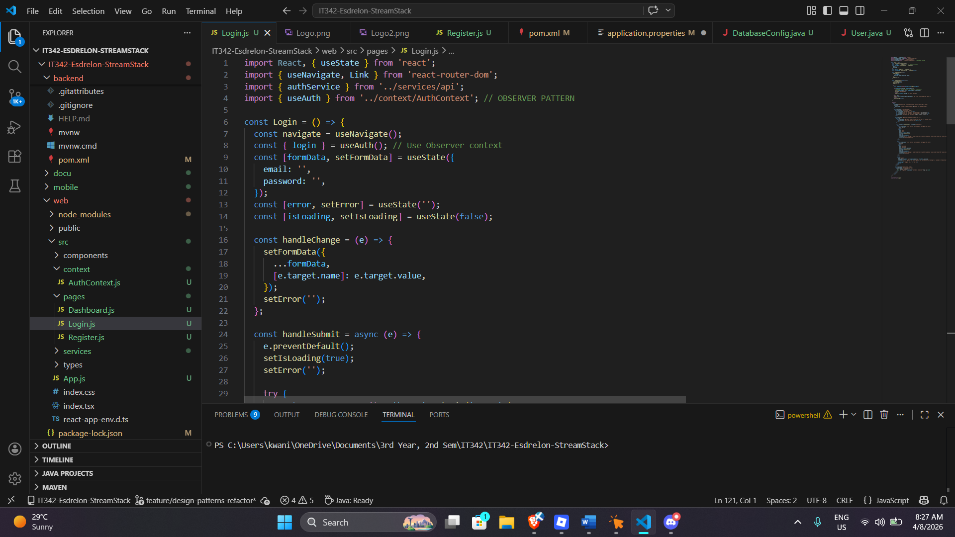
Benefits of Observer Pattern:
- Automatic updates across all components
- Loose coupling between components
- Easy to add new observers
- Centralized state management

PATTERN 5: PROXY PATTERN
Location: Backend - Security & Authorization
The Original Implementation [BEFORE (Without Proxy)]
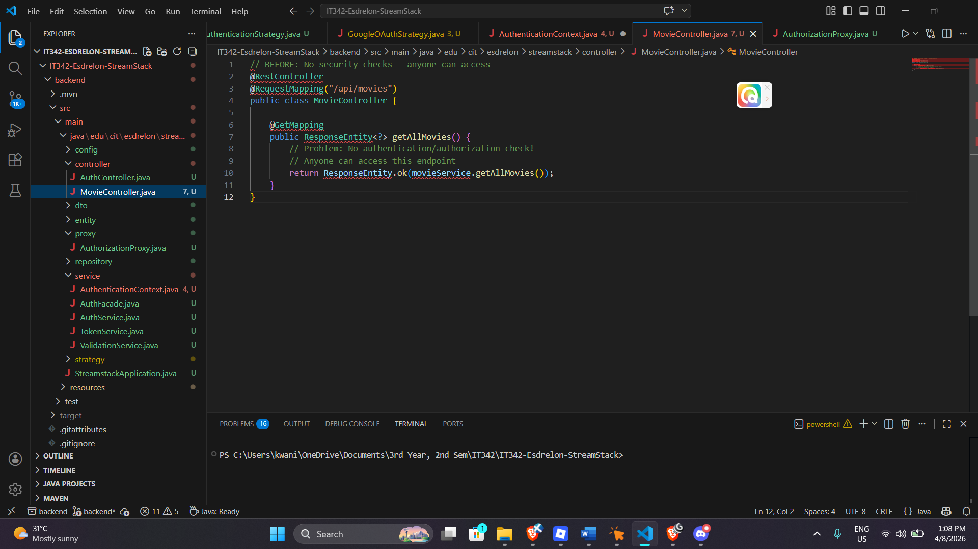
Problem: No authorization checks before accessing protected resources.
After the Implementation [AFTER (With Proxy Pattern)]
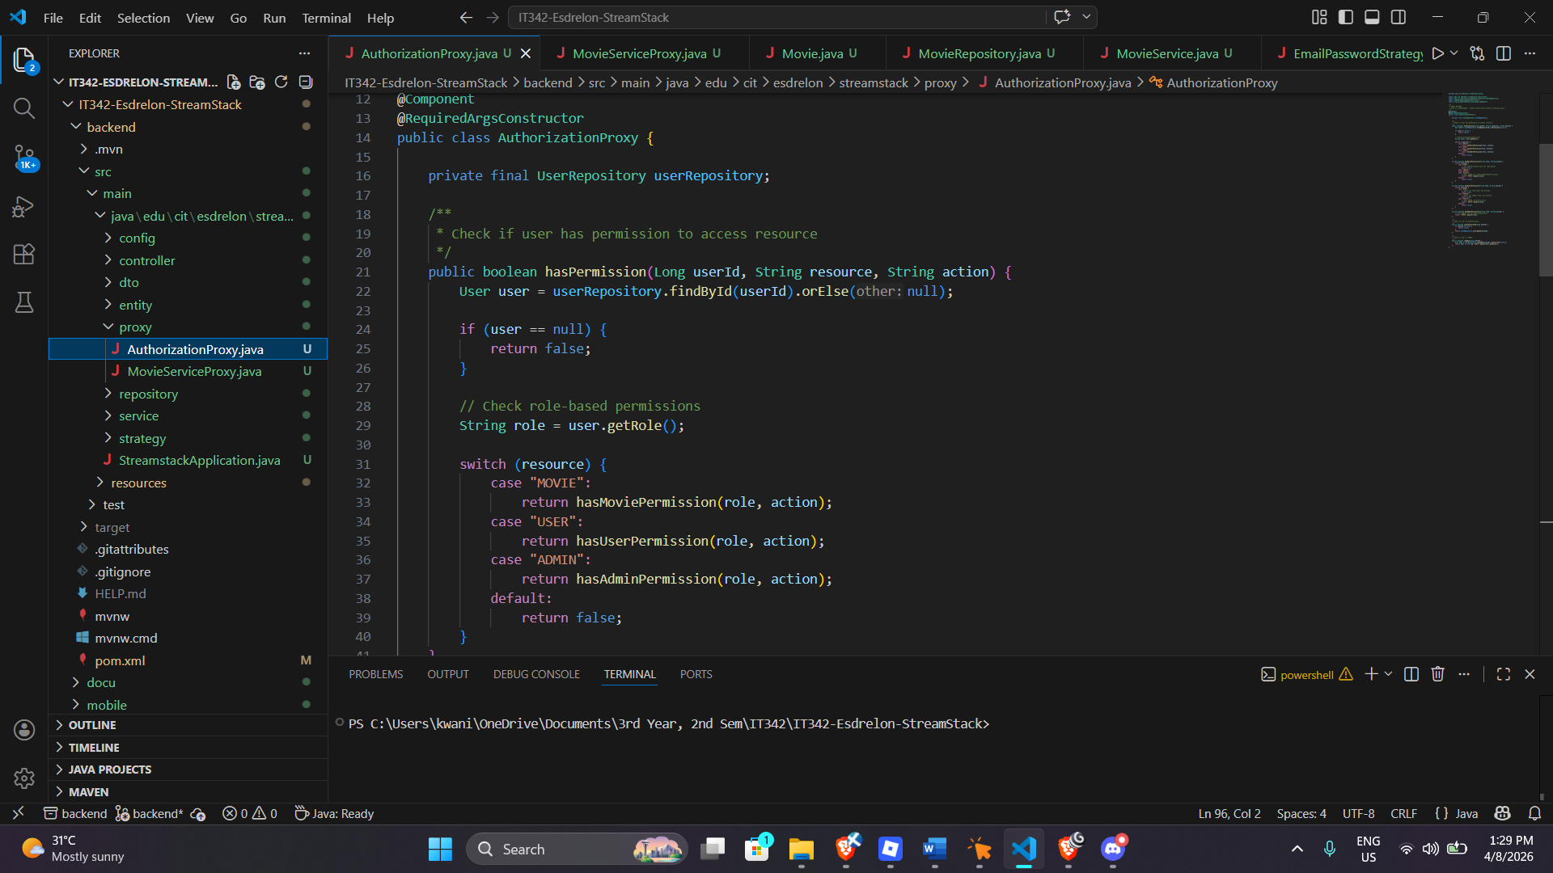
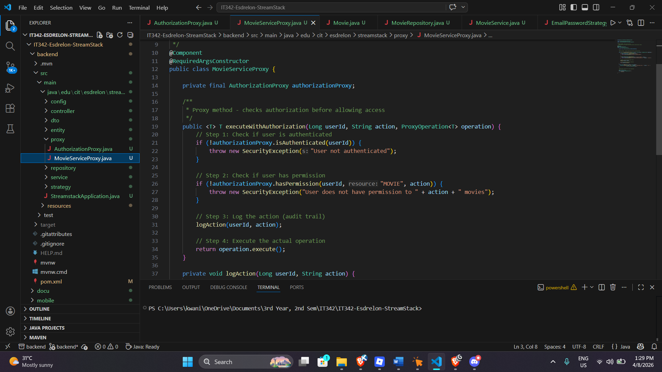
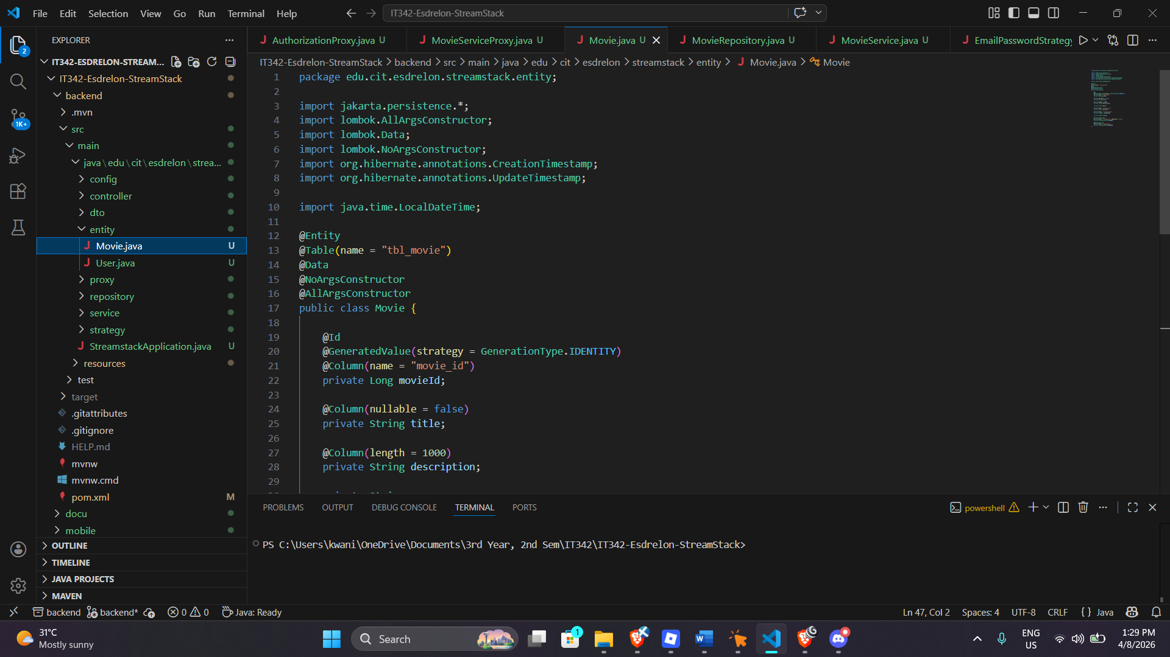
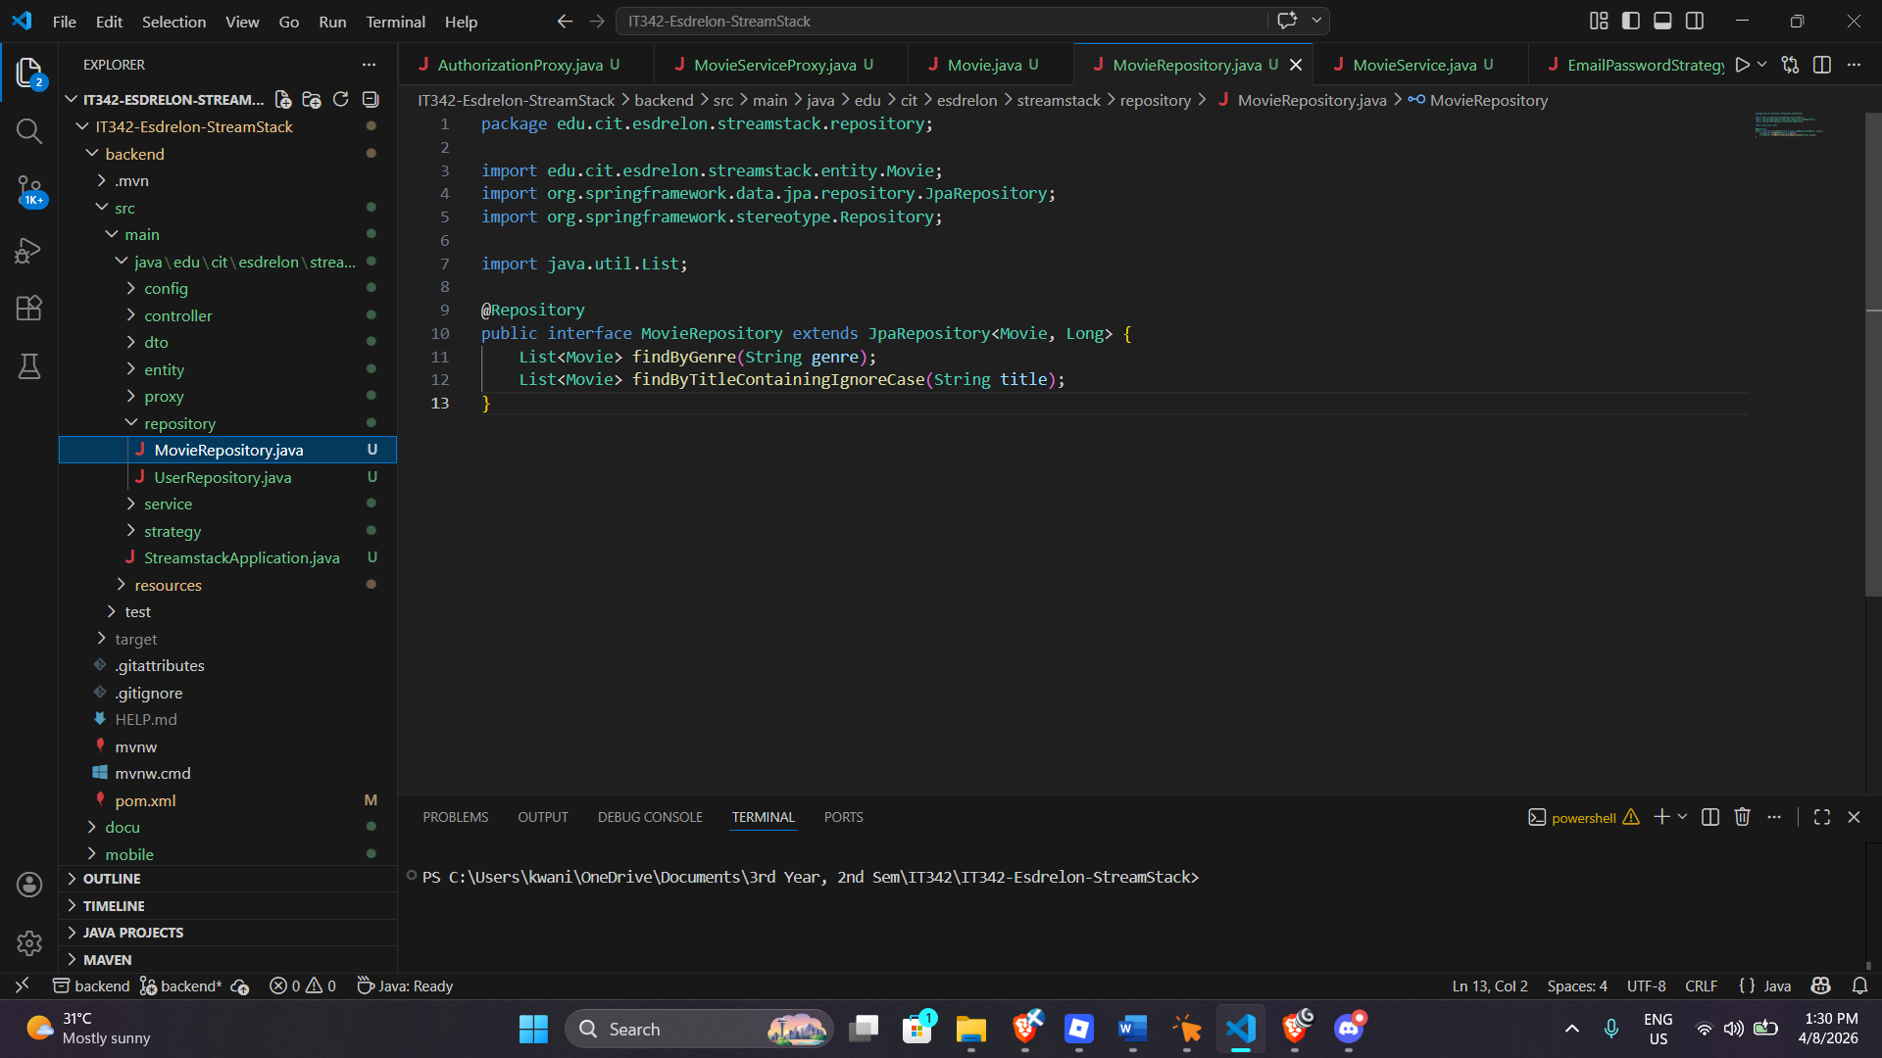
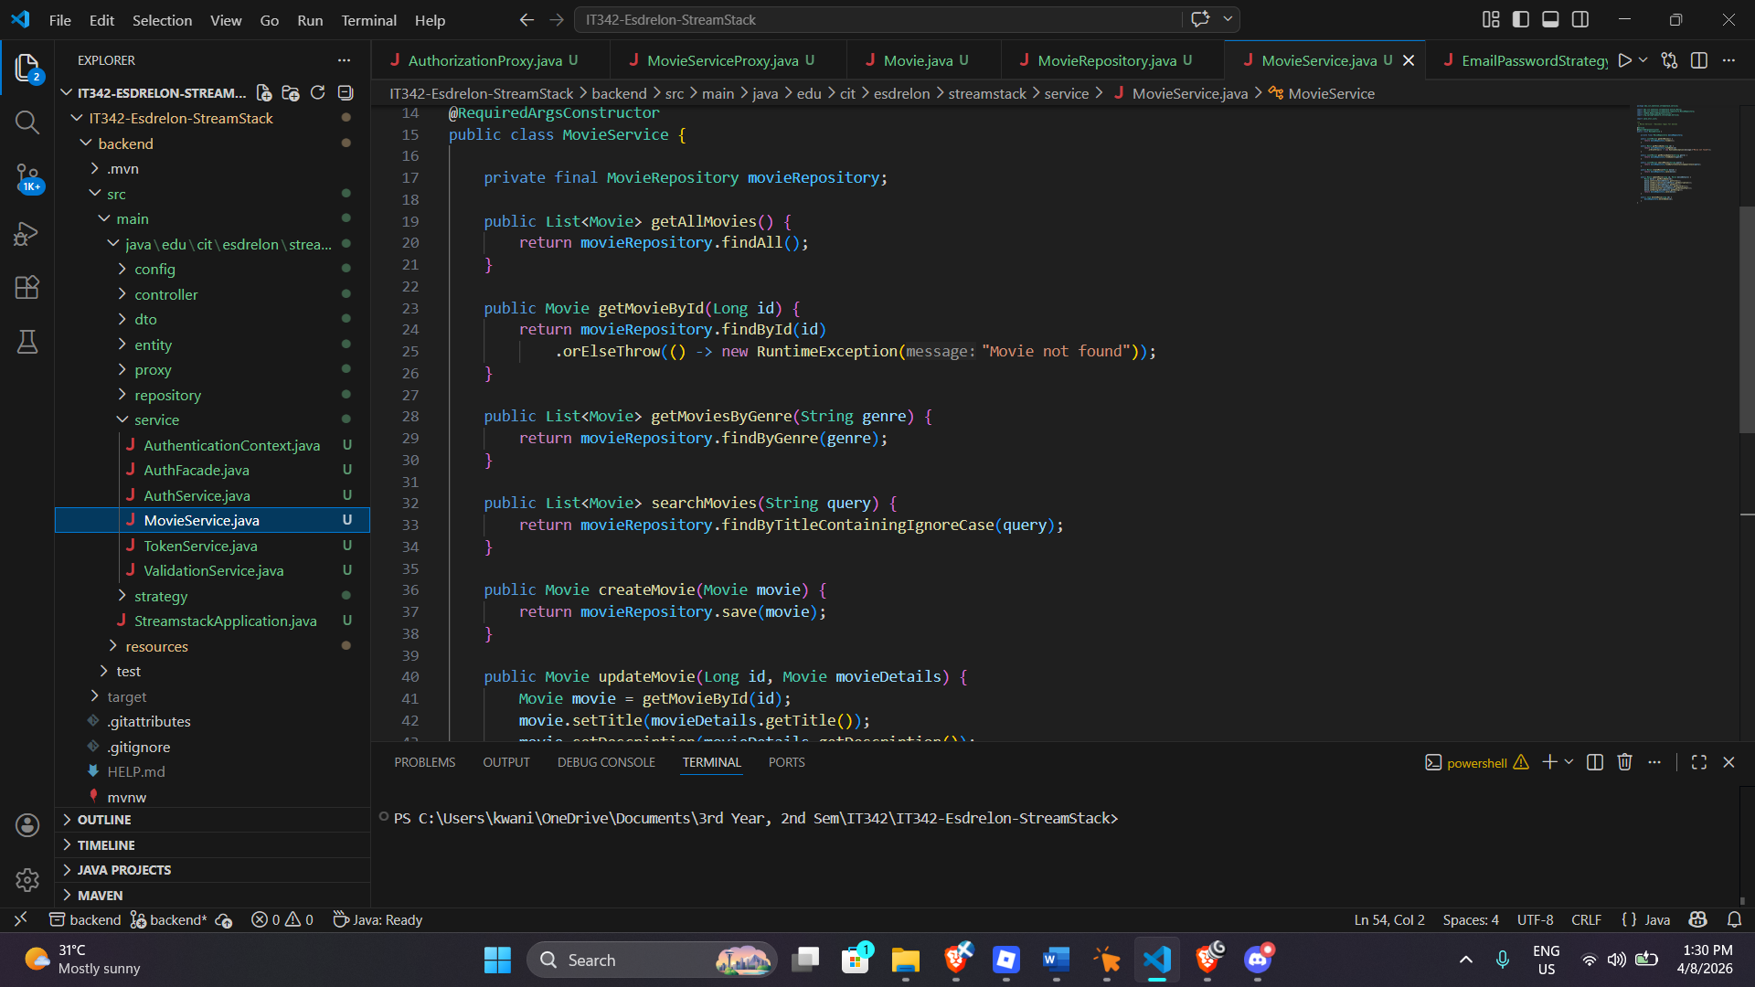
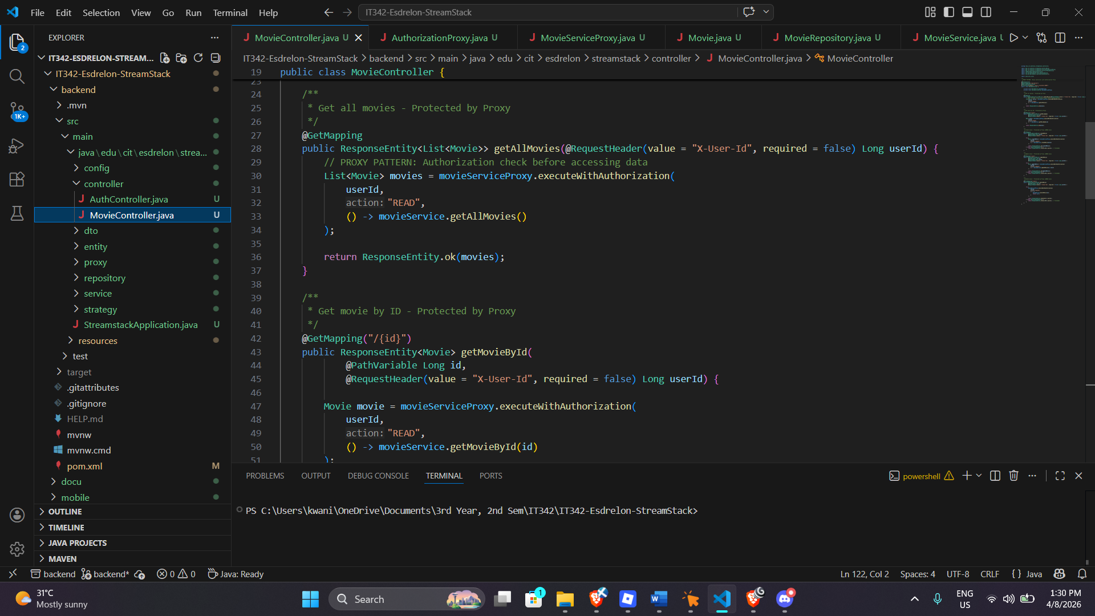
BENEFITS OF PROXY PATTERN:
- Authorization checks before any operation
- Logs all actions for compliance
- Security logic separated from business logic
- Change authorization rules in one place

